Problem (1):
Output & Discussion:
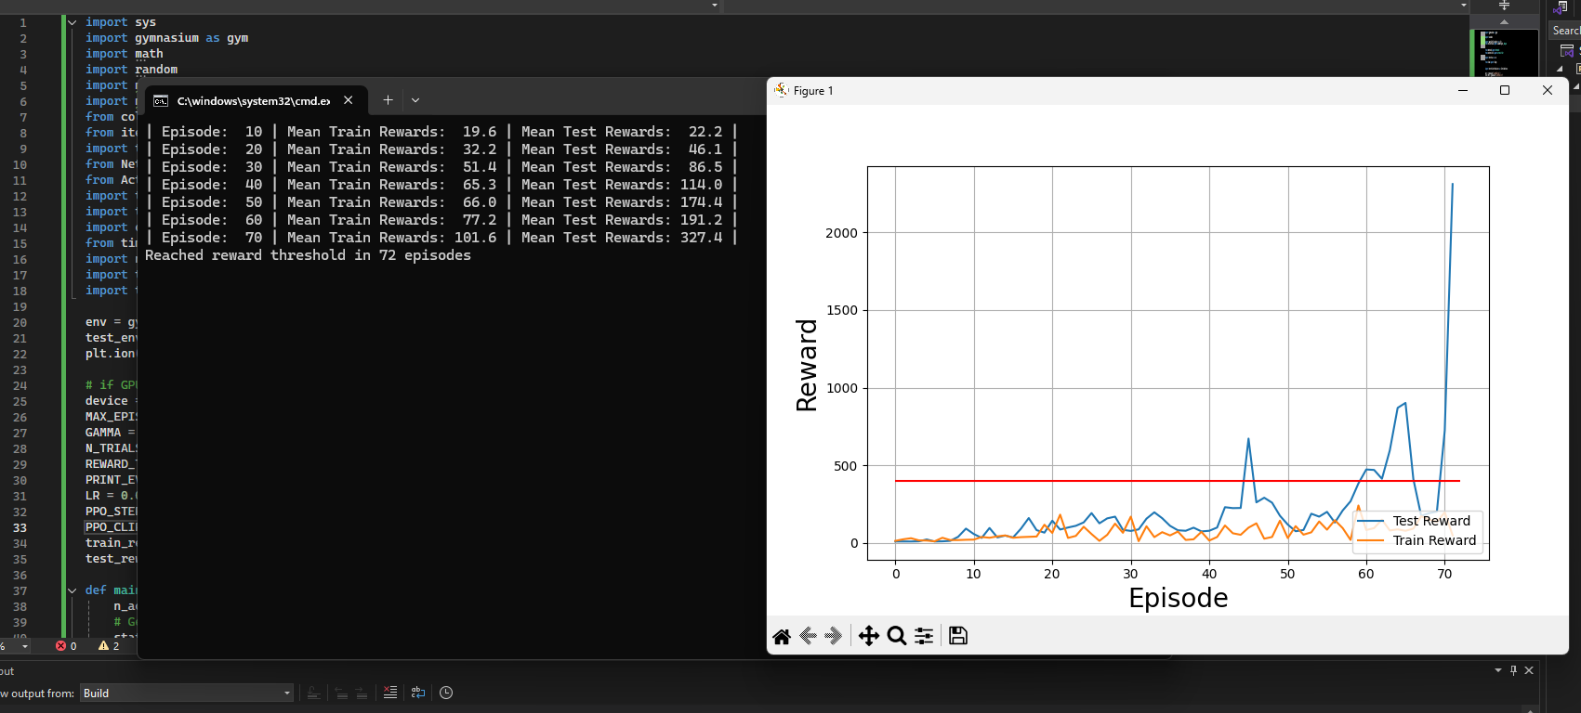
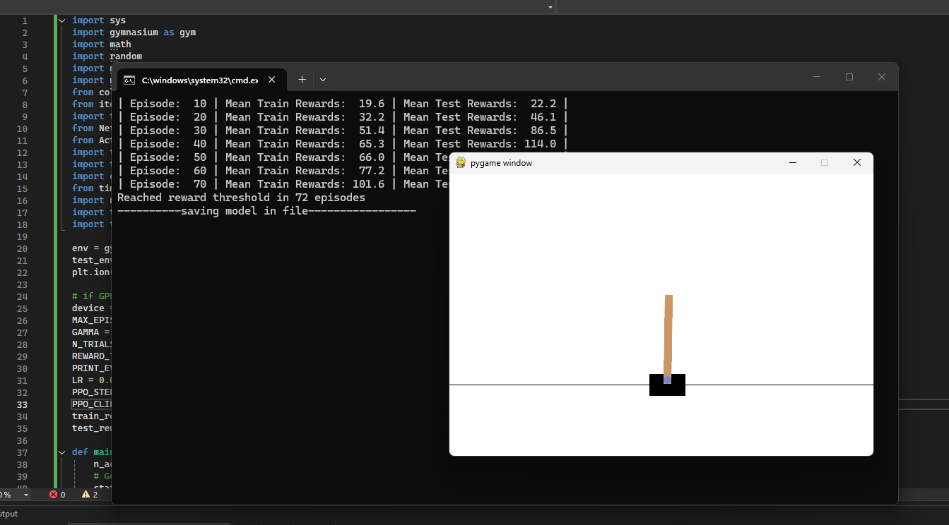
Discussions
The implementation of the Advantage Actor-Critic (A2C) algorithm shows how combining an actor and a critic improves learning stability and performance. The actor selects actions while the critic evaluates state values, and the advantage function helps reduce variance, leading to more reliable updates. This results in smoother and faster convergence compared to traditional policy gradient methods.
Additionally, A2C can be viewed as a simplified and stable version of more advanced methods like A3C, highlighting its importance as a foundation for modern reinforcement learning algorithms. The concept of optimizing both policy and value functions together also demonstrates an effective balance between bias and variance. Furthermore, techniques such as entropy regularization and extensions to PPO show how these methods can be improved for better exploration and sample efficiency.
Overall, this problem not only demonstrates the effectiveness of A2C but also provides insight into how modern reinforcement learning algorithms evolve toward more stable and efficient learning frameworks.

